**Test Approach**

**Application – Buggy Cars Rating (https://buggy.justtestit.org/)**

**Initial Exploratory Testing -**

1. Load the website.
2. Observe all pages, look for any potential HTML layout misalignment
3. Try the features and functionalities, internal and external links.
4. View cars and their comments, vote count.
5. Check if Rank field is displayed as per vote count.
6. Vote a car without login in.
7. Give unregistered / Random Login details and try logging in.
8. Test registration feature. Check mandatory Form fields, error message.
9. Login
10. Test vote feature and check if master count has incremented for that car and the model.
11. Check if total vote counts of each car make tallies with sum of individual brand’s model vote count.
12. Test profile page fields
13. Decide on Testing Tools, Model, framework.
14. Implement them to get maximum code coverage.

**Functional Requirements -**

1. Validate Popular Make - Identify distinct car Makes. Find the total votes of each car make by adding individual votes of each model group by the same make. The make with the highest vote is considered popular make

2. Validate Popular Model - Identify Popular Model. Any Model with the highest individual votes irrespective of Make that it belongs to is considered Popular Model

3. Overall Rating - Validate whether the Rank for each Model is determined correctly. Rank should be sorted ascendingly depending upon the number of votes. Higher the votes lower the Rank. The rank should be the same for all cars having the same votes

4. Page Navigation/Hyperlink: Verify whether we can navigate from home page to all the other pages and can come back to home page. Verify for broken link in each and every page

5. Display of Images - Verify whether the image is displayed in each and every page i.e., check for broken image or image not being displayed

6. Order by Make: Verify whether all the models are displayed for that Make along with Model Name, Rank , Votes and Comments

7. Validate Voting functionality: Verify whether you can vote for a model only if you are logged in and you haven't casted your vote previously for that model. Verify whether Vote count is increased by 1 after successfully casting the vote. After casting the vote, the table below the Model description should display the Date vote has been casted, Author and Comment. It should display all the records from day 1 the application is running from

8. Verify sort order for Overall Rating page for each of the columns i.e., Make, Model, Rank, Votes, Engine

9. Pagination - Verify whether the pagination i.e., scrolling of pages happens under Overall Rating

10. Logout - Verify user can Logout from each and every page if the user is logged increased

11. Login - verify the user can Login successfully with valid credentials

12. Error message validation - Verify error message is displayed during invalid action example: Invalid username/password

13. Verify whitespace character is trimmed in the username field

14. Profile check & Update - Verify user is able to update profile information once they have logged in

15. Verify Field level validation across all the pages

16. Verify the respective functionalities of all the buttons across all the pages

17. Registration - Verify new registration is successful. Login name is the primary key and it should be case insensitive and unique

18. Register feature should not be visible once logged in

19. Greeting image is displayed saying Hi, Firstname after successful login

20. Verify Field length validation across all pages

**Non Functional Requirements:**

1. Page Load: Each page must be loaded within 2 seconds

2. Registration: Registration should happen in 2 seconds

3. Number of concurrent Users: 10000 concurrent users

4. Compatibility: Support different browsers including Chrome, Firefox, Internet Explorer and Safari

5. Usability: Application should be compatible to be viewed in Mobile devices

**Security requirements:**

1. Testing for Cross Site Scripting

2. Check for Broken Authentication and Session Management

3. Check for Sensitive Data Exposure

**Testing in Website** : [https://buggy.justtestit.org](https://buggy.justtestit.org/)

1. **Registration page Last name field displays incorrect error message.**

**Page:** Registration page

**Expected Result:** Lastname when blank should display ‘Last Name is required’.

**Actual Result:** displayed incorrect error message – ‘First Name is required’.

**Reproducing:** Open the website. Go to registration page by clicking Register button on top right. Fill Last name field and clear the field.

**Priority :** 3

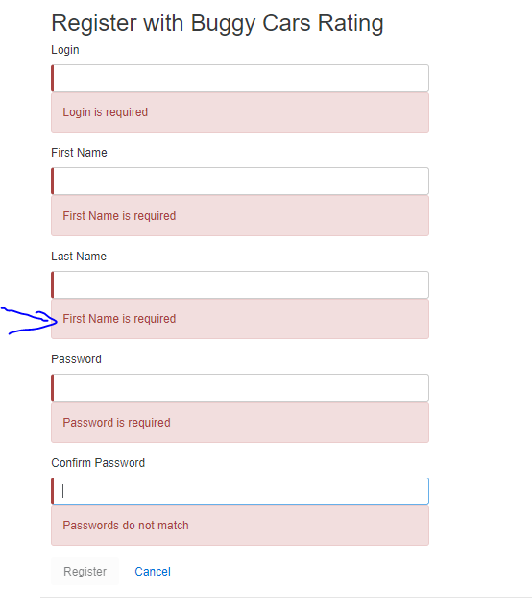

1. Car Image Broken

Page: Over All car list Page

Expected Result: Display all images correctly

Actual Result: Image is broken.

Reproducing Steps: Launch the website. Click on Over All Rating image. Go to 4th page and [Lancia](https://buggy.justtestit.org/make/c4u1mqnarscc72is013g) make, [Ypsilon](https://buggy.justtestit.org/model/c4u1mqnarscc72is013g%7Cc4u1mqnarscc72is0150) model’s image is broken.

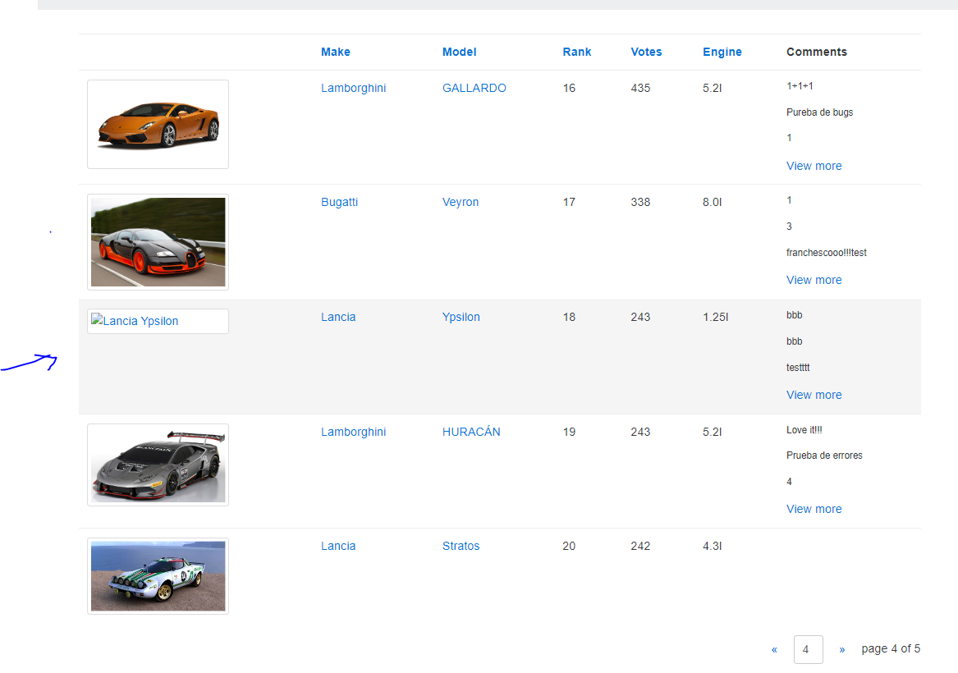

1. **Comment Author Name not displayed**

**Page:** When inside any particular car model page.

**Expected Result: ‘**Author’ column in comments section to be populated.

**Actual Result: ‘**Author’ column is blank while Date, Comment fields are populated.

**Reproducing:** Launch the website. Click on one of the Main menu image to view the list of cars (in the screenshot below, I have clicked on the third image from left that is – ‘List of all registered models’). Click on a car model (in the screenshot below, I have clicked on [Guilia Quadrifoglio](https://buggy.justtestit.org/model/c4u1mqnarscc72is00ng%7Cc4u1mqnarscc72is00sg)). Comments section table is displayed at the bottom of the page. Author column is blank.

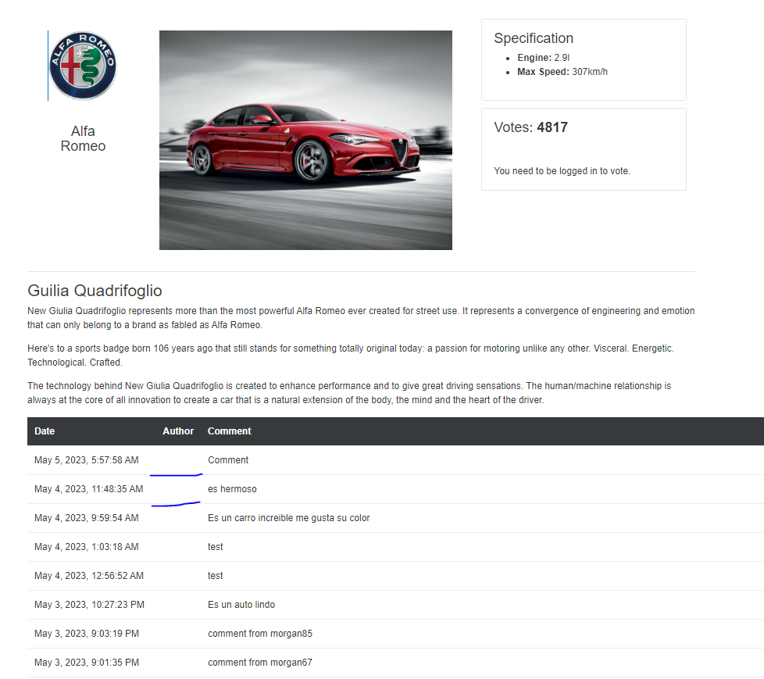

1. **Wrong Error Message displayed in Profile Page**

**Page:** Profile Page

**Expected Result:** Display Correct Error message such as ‘Invalid value entered in Age field’.

**Actual Result:** Displays error – **‘**Get a candy ;)’

**Reproducing Steps:** Launch website. Login -> Go to profile page -> add invalid value like a space or an alphabet in the Age field -> Save. Error message **‘**Get a candy ;)’ displayed.

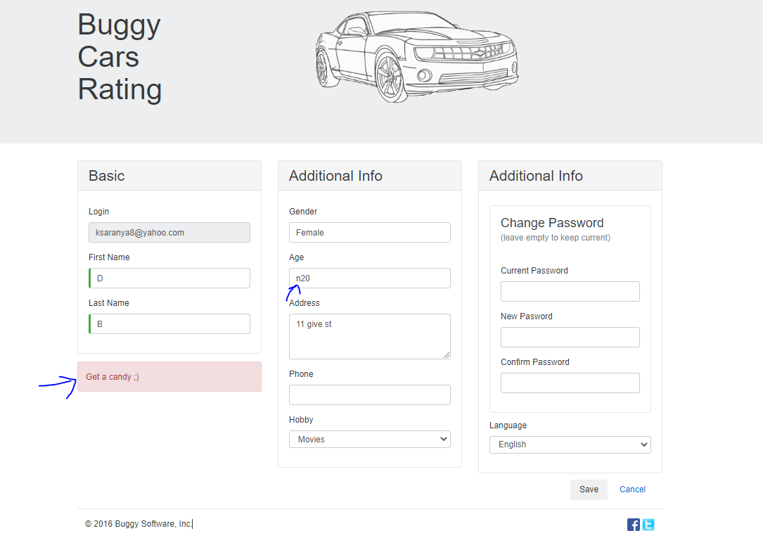

1. **Invalid Gender gets saved**

**Page**: Profile Page

**Expected Result:** Should be a dropdown, if not, then should give error message when invalid format is entered.

**Actual Result:** Invalid entry is accepted. No error message is displayed.

**Reproducing steps:** Launch the website -> Login -> Go to profile page -> enter number in Gender field. Enter Save. Profile gets updated without any error message.

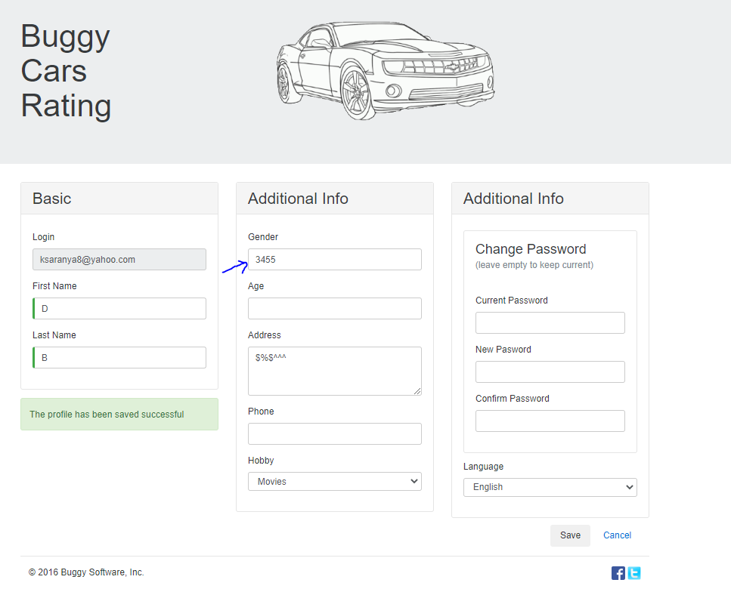

1. **Unknown Error – Knitting option selected in Hobbies in Profile page.**

**Page**: Profile Page

**Expected Result:** ‘Knitting’ option when chosen under Hobbies, should save successfully.

**Actual Result:** ‘Knitting’ option when chosen under Hobbies, displays ‘Unknown error’ when saved.

**Reproducing steps:** Launch the website -> Login -> Go to profile page -> Select ‘Knitting’ from Hobby drop down. Click Save button. ‘Unknown error’ message displayed.

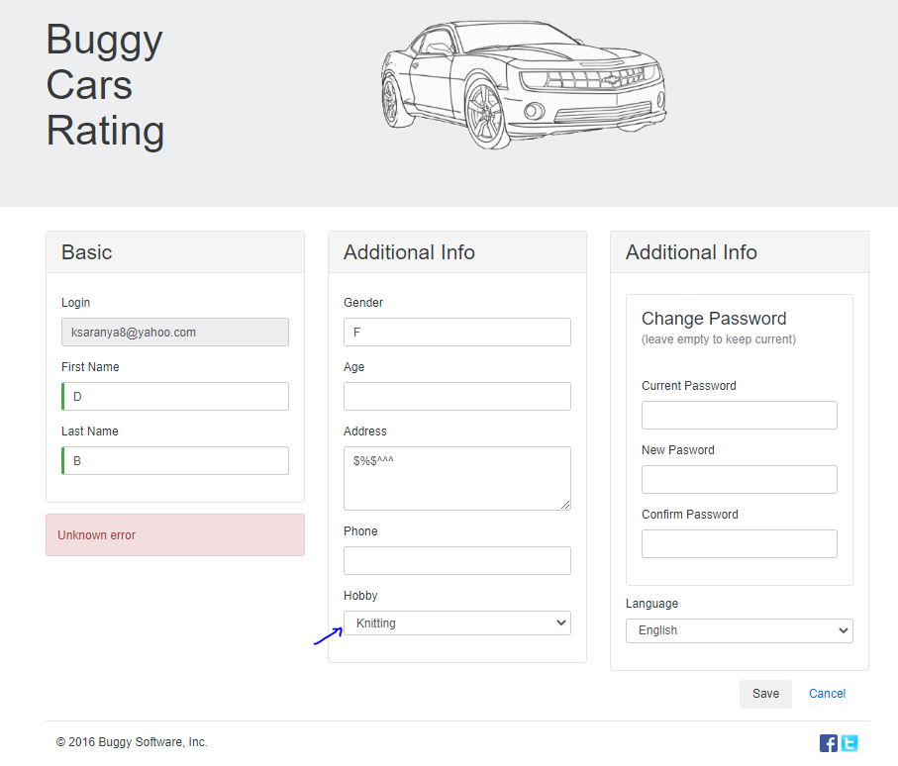

1. **Cursor displayed near images and tables**

**Page**: Dashboard and in all pages

**Expected Result:** Page display fine without any cursors on the displayed web content.

**Actual Result:** Cursor appears in all displayed texts, near image, tables.

**Reproducing steps:** Launch

the website -> Hover over the link text and click on it.

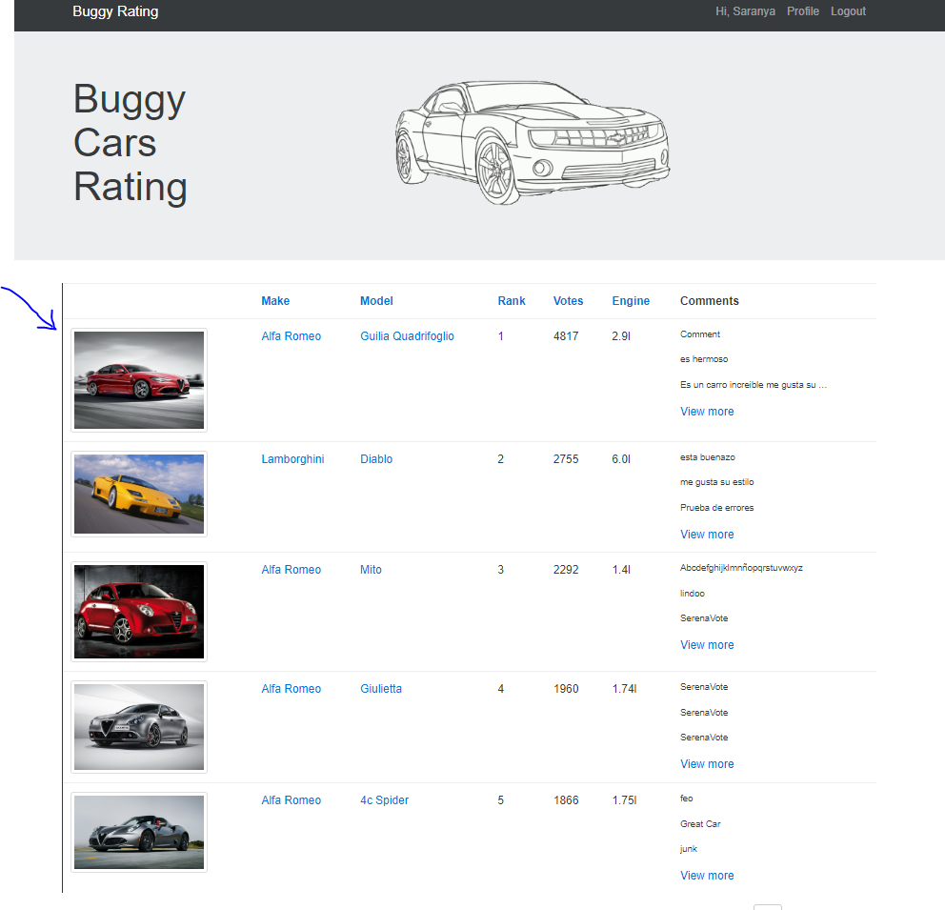 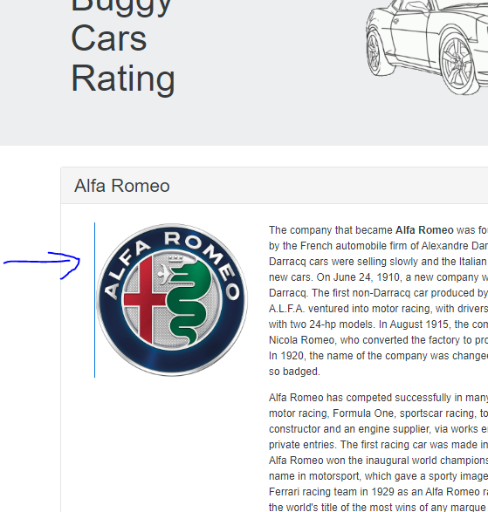

1. **OverAll Page navigation page numbers incorrect**

**Page:** OverAll Rating List page

**Expected Result:** ‘Next’ navigation button should be disabled when user reaches the last page.

**Actual Result:** Page lets user to navigate indefinitely.

**Reproducing Steps:** Launch website. Click on overall rating image. Click next button at the bottom of the page until you reach more than the total page count.

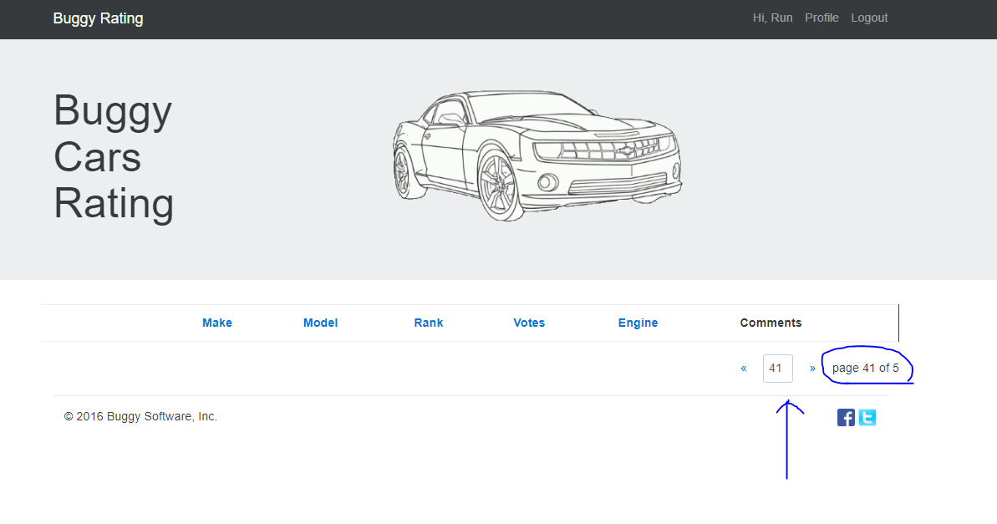

1. **Logo to take the user to home page when clicked.**

**Page:** List of Cars in a make page

**Expected Result:** Clicking on ‘Buggy Rating’ link on top left should take user to home page.

**Actual Result:** When clicked, the page remains the same. User is stuck on this page.

**Reproducing steps:** Launch the website. Click on one of the Main menu image to view the list of cars. Now click on Top Logo ‘Buggy Rating’.

**Priority:** 2, Severity: 1

